VULNERABILITY ASSESSMENT AND
PENETRATION TESTING (VAPT) REPORT
Target Environment: Metasploitable 2 and DVWA (Damn Vulnerable Web Application)

Prepared For MCA - Ethical Hacking & Penetration Testing (Assignment Question 20)
Student Vishal Chudasama
Enrollment Number 25004401110069
Division E02

Assessment Platform Kali Linux (running in VMware Workstation)
Target Host 192.168.184.130 (Metasploitable 2, isolated lab network)
Assessment Date 10 October 2026
Report Type Internal Academic Lab Assessment - Confidential

This assessment was performed exclusively within an isolated, authorized academic lab environment against intentionally vulnerable training systems. Findings do not reflect any production system and must never be applied against systems without explicit written authorization.

Table of Contents
1. Executive Summary 3
2. Scope and Methodology 3
2.1 Scope 3
2.2 Methodology 3
3. Tools Used 4
4. Vulnerabilities Identified 4
5. Technical Findings 5
5.1 Network Service Enumeration (Nmap) 5
5.2 Web Server and Application Surface Enumeration 6
5.3 PHP Information Disclosure — /phpinfo.php (V-04) 8
5.4 Exposed Administrative Interface — phpMyAdmin (V-05) 8
5.5 SQL Injection — DVWA SQL Injection Module (V-02) 9
5.6 OS Command Injection — DVWA Command Execution Module (V-01) 10
5.7 Weak / Default FTP Credentials — Dictionary Attack with Hydra (V-03) 11
6. Evidence and Screenshots Register 12
7. CVSS Scoring 13
8. Business Impact 14
9. Remediation Recommendations 14
10. Assessment Limitations 15
11. Conclusion 15

1. Executive Summary

This report presents the results of a Vulnerability Assessment and Penetration Testing (VAPT) exercise conducted as practical coursework for the MCA programme module "Ethical Hacking & Web Application Security." The objective was to simulate a structured security assessment against an authorized, intentionally vulnerable lab target and to document the discovered weaknesses using an industry-style reporting format.
The target environment consisted of a single host, 192.168.184.130, running Metasploitable 2 with the Damn Vulnerable Web Application (DVWA) deployed on it, both operating inside an isolated virtual lab network alongside a Kali Linux attacker machine. Network reconnaissance with Nmap identified 23 open TCP ports exposing a broad range of legacy and high-risk services.
Hands-on testing confirmed several high-impact vulnerabilities: an SQL Injection flaw in DVWA that discloses the full contents of the application's users table, an OS Command Injection flaw that executes arbitrary operating-system commands as the web server's service account, and a weak/default FTP credential pair (msfadmin) recovered through a dictionary attack with Hydra. In addition, an exposed phpinfo.php script and an unauthenticated phpMyAdmin interface were found to disclose server configuration details and expand the host's attack surface, and Nmap's service banner for port 1524 identified a pre-installed backdoor shell characteristic of this training VM.
Collectively, these findings represent a critical overall risk posture consistent with a deliberately vulnerable system, and they illustrate — in a safe, authorized setting — the real-world consequences of unpatched software, missing input validation, and weak credential hygiene. Section 9 (Remediation Recommendations) presents prioritized, actionable guidance for each finding; Sections 5 through 8 provide the supporting technical evidence, CVSS ratings, and business-impact context.

2. Scope and Methodology

2.1 Scope
Testing was confined to a single authorized lab target: the Metasploitable 2 virtual machine at 192.168.184.130 and its hosted DVWA instance, reachable only within an isolated virtual network shared with the Kali Linux attacker machine used for this exercise. No external, third-party, or production system was in scope at any point. DVWA's internal "Security Level" setting was left at Low and PHPIDS was disabled throughout testing, exactly as configured for this lab exercise; this materially lowers the difficulty of exploitation and is taken into account when assessing severity in Section 7.

2.2 Methodology
The assessment followed a condensed VAPT lifecycle, adapted for a classroom exercise:
- Reconnaissance & Service Enumeration — TCP port discovery and service/version fingerprinting with Nmap.
- Web Application Enumeration — HTTP method, header, and directory/path enumeration using Nmap NSE scripts and curl.
- Vulnerability Identification — manual testing of DVWA's SQL Injection and Command Execution modules, and dictionary-based credential testing against FTP.
- Validation — each finding was manually reproduced and screenshotted at the point of discovery, so every claim is backed by first-hand evidence.
- Reporting — findings consolidated, severity-rated with CVSS v3.1, mapped to root causes, and paired with remediation guidance.
No automated vulnerability scanner (e.g., Nessus, OpenVAS), web application proxy (e.g., Burp Suite), or exploitation framework (e.g., Metasploit module execution) was used in this exercise; all testing was performed with command-line tools and a standard web browser, consistent with the tool set specified for this assignment. This boundary is revisited in Section 10 (Assessment Limitations).

3. Tools Used

The following tools and platforms were used during reconnaissance, testing, and evidence capture.
Tool / Platform | Version (as observed) | Purpose in this Assessment
Kali Linux | 2026 rolling (attacker VM) | Primary testing platform for all command-line tools
Nmap | 7.99 | TCP port scanning, service/version detection, HTTP enumeration via NSE scripts
Hydra | v9.7 | Dictionary-based credential testing against the FTP service
cURL | system default | HTTP status / header verification of discovered web paths
Mozilla Firefox | system default | Manual testing of DVWA, phpMyAdmin, and phpinfo.php
DVWA | v1.0.7 (Security Level: Low) | Target vulnerable web application (SQL Injection, Command Execution modules)
Metasploitable 2 | — | Intentionally vulnerable target host (192.168.184.130)

4. Vulnerabilities Identified

The table below summarizes every finding confirmed or observed during this assessment. Detailed evidence and analysis for each is provided in Section 5; CVSS ratings are in Section 7.
ID | Vulnerability | Affected Component | Evidence | Severity
V-01 | OS Command Injection | DVWA — Command Execution module | Fig. 6 | High
V-02 | SQL Injection | DVWA — SQL Injection module | Fig. 5 | High
V-03 | Weak / Default FTP Credentials | vsftpd 2.3.4 (port 21/tcp) | Fig. 7 | Critical
V-04 | PHP Configuration Information Disclosure | /phpinfo.php | Fig. 3 | Medium
V-05 | Exposed Administrative Interface | /phpMyAdmin/ | Fig. 4 | Low
V-06 | Pre-installed Backdoor Service (identified, not exploited) | Port 1524/tcp — "Metasploitable root shell" | Fig. 1 | Critical (potential)
V-07 | Outdated & Legacy Network Services (aggregate) | Telnet, rsh/rexec, NFS, SMB, VNC, UnrealIRCd, Tomcat, PostgreSQL | Fig. 1 | Medium (aggregate)

5. Technical Findings

This section presents each finding in the order it was discovered during testing, with description, supporting evidence, technical impact, root cause, and severity. Confirmed observations are clearly distinguished from potential, unverified risk throughout.

5.1 Network Service Enumeration (Nmap)
A full TCP service and version scan was run with the command nmap -sV -sC -oN q20_nmap.txt 192.168.184.130. The scan completed in 257.96 seconds and reported the host up with 977 filtered ports and 23 open TCP ports — an unusually large exposed surface for a single host, typical of a deliberately vulnerable training system.
Notable services identified include: vsftpd 2.3.4 (port 21), OpenSSH 4.7p1 Debian (port 22), a Linux Telnet daemon (port 23, cleartext protocol), Postfix smtpd (port 25), ISC BIND 9.4.2 (port 53), Apache httpd 2.2.8 with WebDAV (port 80), rpcbind (111), Samba smbd (139/445), netkit-rsh rexecd and r-login/r-shell services (512–514, all cleartext legacy protocols), a GNU Classpath Java RMI registry (1099), MySQL (3306), PostgreSQL 8.3.x (5432), VNC with weak authentication (5900), an unauthenticated X11 server (6000), UnrealIRCd (6667), and Apache Tomcat/Coyote (8009, 8180). Most notably, Nmap's service banner for port 1524/tcp self-identified as a "Metasploitable root shell" (bindshell) — a pre-installed backdoor characteristic of this intentionally vulnerable VM. In line with the defined scope of this exercise, this service was recorded from the scan output only; it was not connected to or exploited, and is flagged in Section 4 (V-06) as a potential, unverified-impact finding rather than a confirmed compromise.
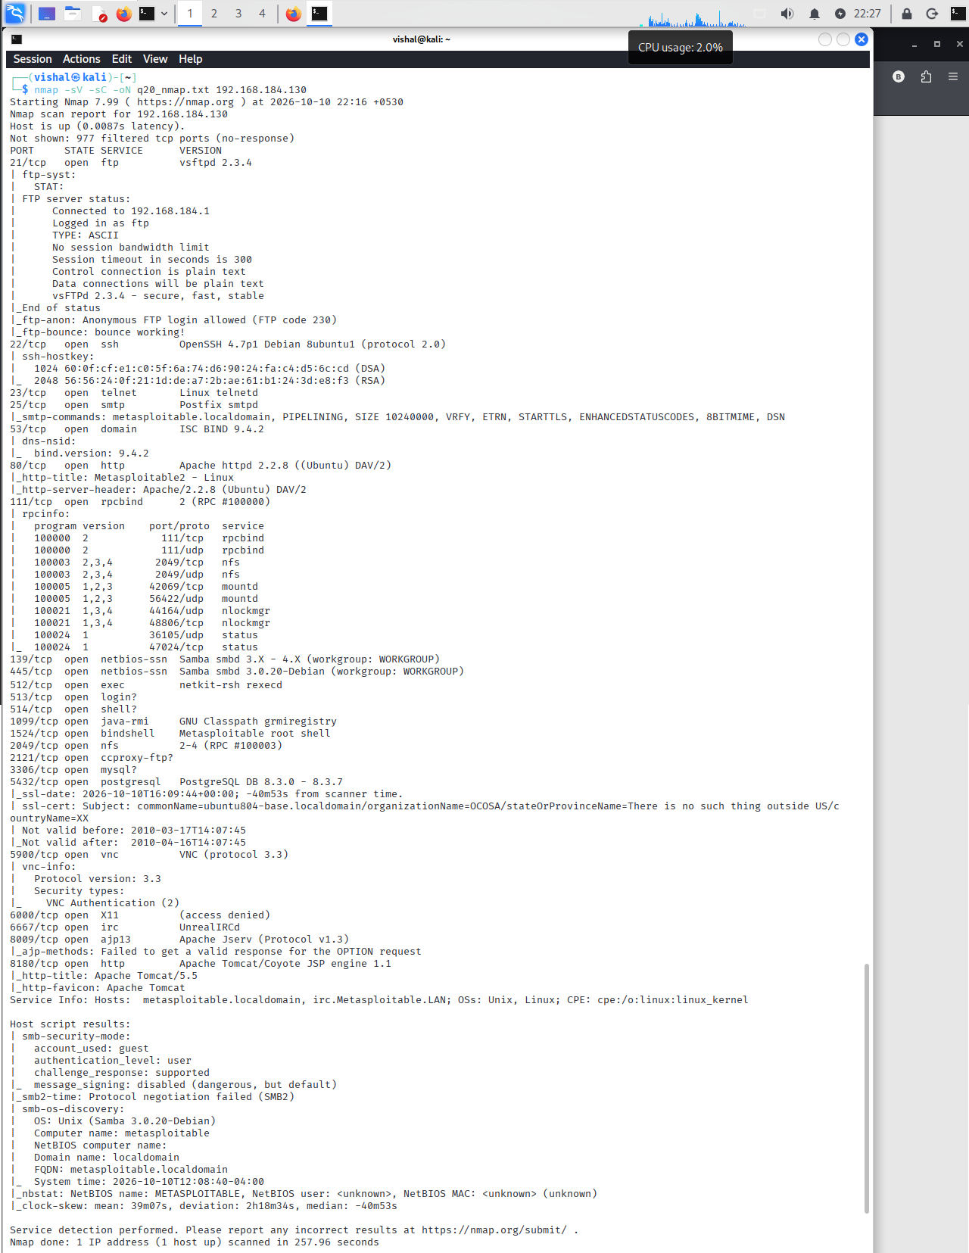
Figure 1: Full Nmap service and version scan (-sV -sC) of 192.168.184.130, confirming 23 open TCP ports including the self-identified backdoor service on port 1524.

5.2 Web Server and Application Surface Enumeration
With port 80 confirmed open, a targeted NSE scan was run: nmap -p 80 --script http-title,http-headers,http-methods,http-enum 192.168.184.130 -oN q20_http.txt. The response headers confirmed Apache/2.2.8 (Ubuntu) DAV/2 with X-Powered-By: PHP/5.2.4-2ubuntu5.10, and the page title identified the application as "Metasploitable2 - Linux." Supported HTTP methods were GET, HEAD, POST, and OPTIONS. The http-enum script discovered several reachable paths, including /tikiwiki/, /test/, /phpinfo.php (flagged by Nmap itself as a "possible information file"), /phpMyAdmin/, /doc/ and /icons/ (both flagged as directories with listing enabled), and /index/.
To confirm reachability, curl was used to check the HTTP status of the two most sensitive discovered paths: curl -s -o /dev/null -w "HTTP Status: %{http_code}" was run against both /phpinfo.php and /phpMyAdmin/, and both returned HTTP 200 — confirming that neither endpoint requires authentication and that both are live on the network. These two endpoints are examined individually in Sections 5.3 and 5.4.
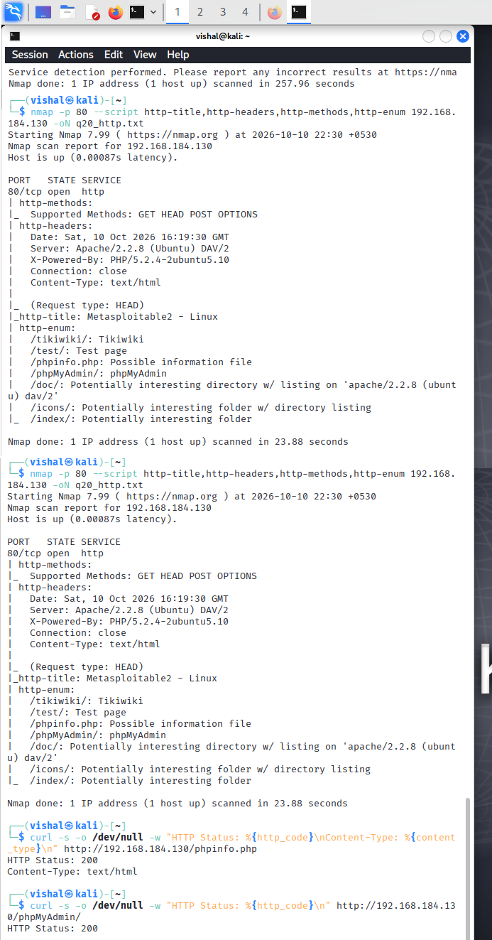
Figure 2: Nmap HTTP enumeration (http-enum / http-headers / http-methods) followed by curl verification, confirming /phpinfo.php and /phpMyAdmin/ both return HTTP 200 without authentication.

5.3 PHP Information Disclosure — /phpinfo.php (V-04)
Browsing directly to http://192.168.184.130/phpinfo.php returned a complete, unauthenticated phpinfo() output.
Evidence: the page discloses PHP 5.2.4-2ubuntu5.10 (a build that reached end-of-life in 2011), the Server API (CGI/FastCGI), the underlying Linux kernel and build date, the full configuration file paths (/etc/php5/cgi, /etc/php5/cgi/php.ini and its conf.d), the loaded PHP extensions, and the registered PHP stream wrappers, socket transports, and filters.
Technical impact (confirmed): the page discloses detailed server-side configuration and exact software version information that materially assists an attacker in fingerprinting known vulnerabilities for this specific PHP build and in planning further, more targeted attacks. No credentials or live session data were observed in the reviewed output.
Root cause: a diagnostic/debug script (CWE-200 — Exposure of Sensitive Information; CWE-215 — Insertion of Sensitive Information into Debugging Code) was left reachable on a publicly accessible path.
Severity: Medium — information disclosure only; no direct code execution was demonstrated through this endpoint.
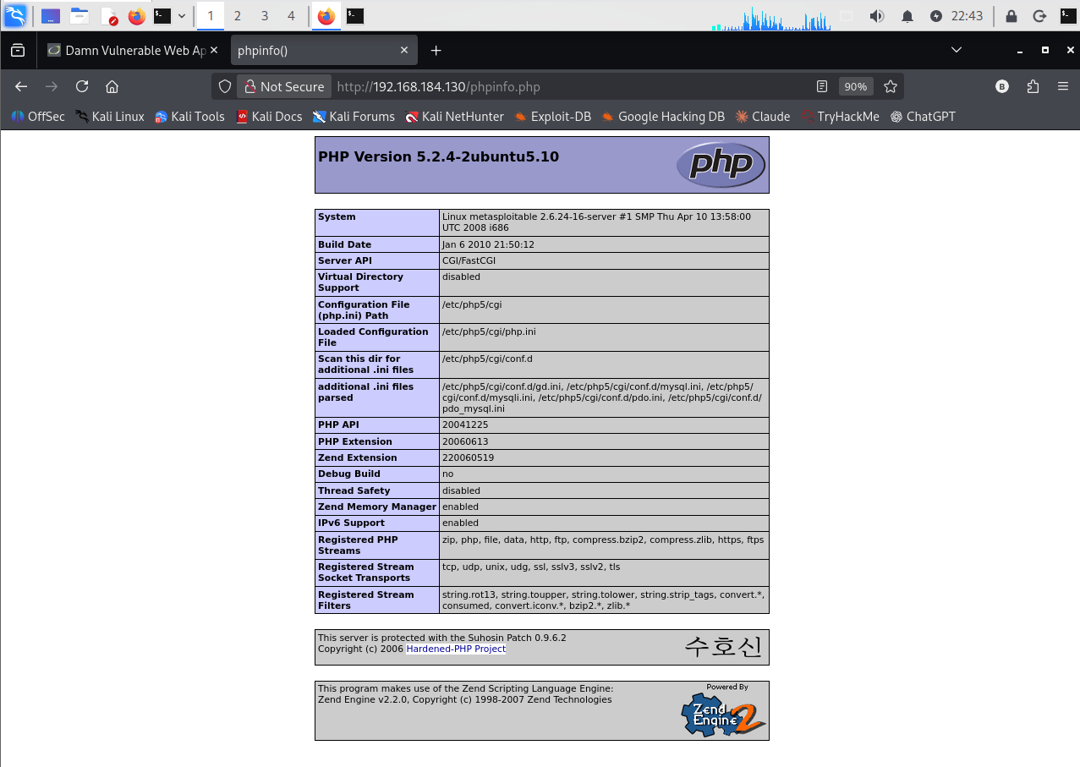
Figure 3: phpinfo() output at /phpinfo.php, disclosing PHP 5.2.4-2ubuntu5.10 configuration and server environment details.

5.4 Exposed Administrative Interface — phpMyAdmin (V-05)
The phpMyAdmin database administration console at http://192.168.184.130/phpMyAdmin/ was reachable over the network without any IP restriction, VPN gating, or additional authentication layer, returning a standard login form. The page also reveals that the backend PHP build is missing the mcrypt extension, a further, minor configuration detail.
Technical impact (confirmed): unauthenticated network exposure of a high-privilege administrative interface, which expands the host's attack surface and would allow an attacker to attempt offline reconnaissance or credential-guessing against the database layer.
Not verified: no login attempt or credential-guessing was performed against phpMyAdmin; further impact remains a potential risk only.
Root cause: CWE-16 (Configuration) — administrative tooling deployed without network-level access control.
Severity: Low, as independently tested; see Section 8 for how this could escalate if combined with weak database credentials.
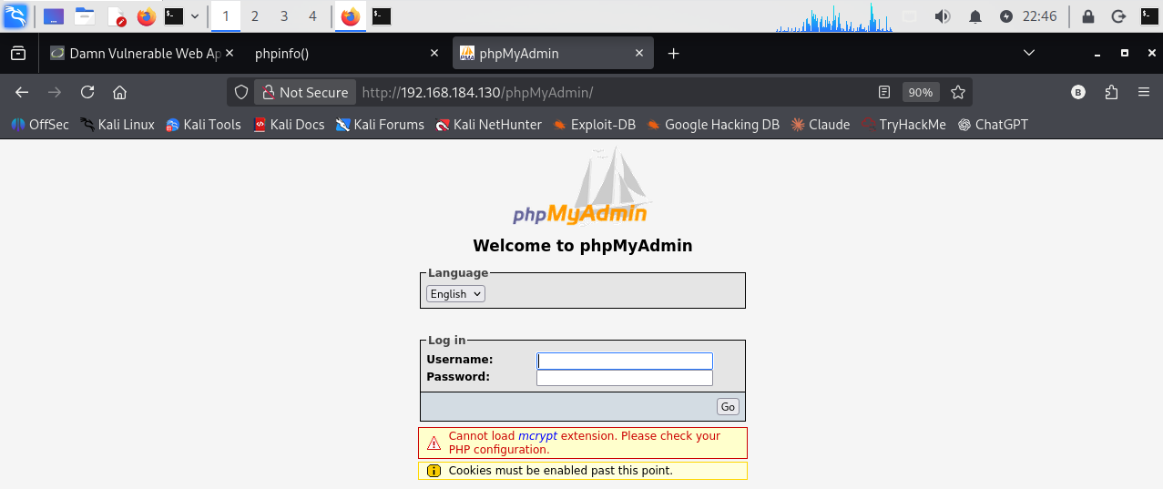
Figure 4: phpMyAdmin login page, confirming the administrative interface is reachable over the network without any access restriction.

5.5 SQL Injection — DVWA SQL Injection Module (V-02)
With DVWA's Security Level set to Low, the "User ID" parameter of the SQL Injection module was tested using the classic payload 1' OR '1'='1' #, submitted through the application while authenticated as the DVWA user admin.
Evidence: instead of the single record normally returned for a valid user ID, the application returned all five rows of the underlying users table: admin/admin, Gordon/Brown, Hack/Me, Pablo/Picasso, and Bob/Smith — directly confirming that user input is concatenated into the SQL query without parameterization or sanitization.
Technical impact (confirmed): unauthorized disclosure of the full contents of the application's users table from what should have been a single-record lookup.
Not verified: write access, DVWA login bypass, or data extraction beyond the users table was not tested; such impact is realistically achievable but is not claimed as confirmed.
Root cause: CWE-89 (SQL Injection) — use of string-concatenated, unparameterized SQL queries.
Severity: High.
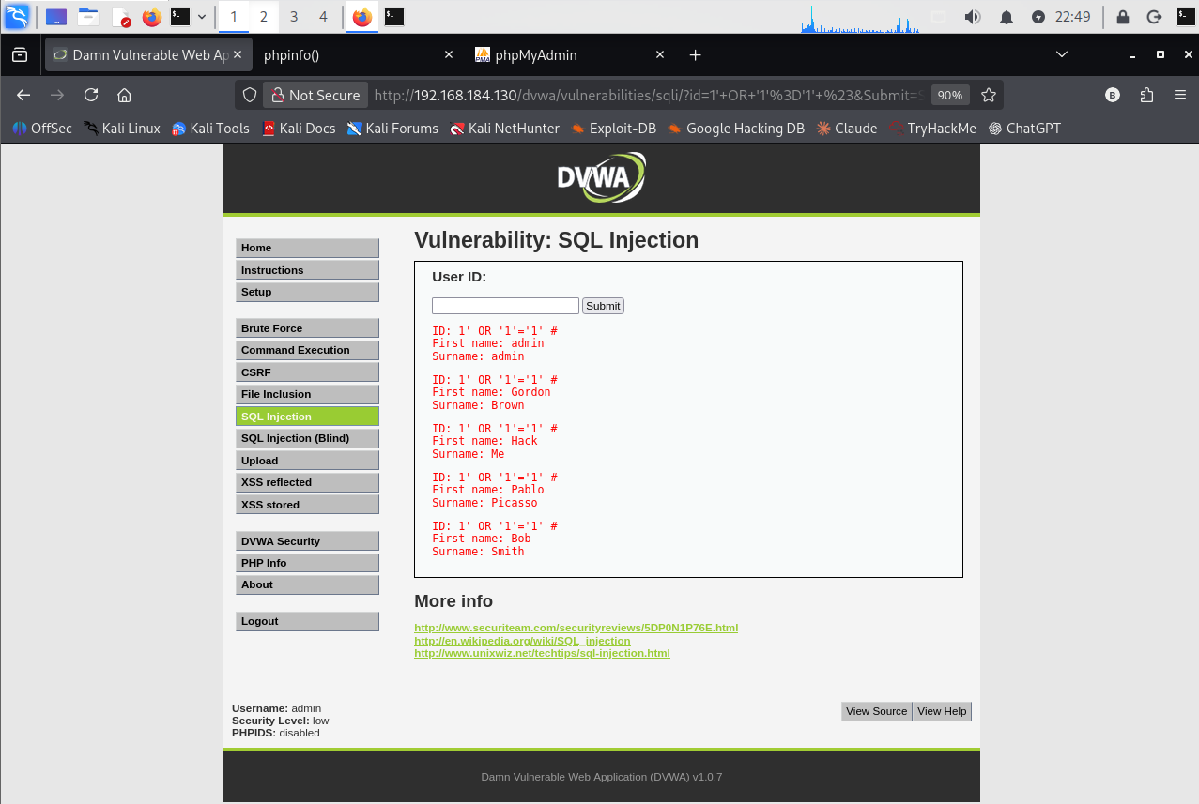
Figure 5: DVWA SQL Injection — the payload 1' OR '1'='1' # returns all five records from the users table instead of one.

5.6 OS Command Injection — DVWA Command Execution Module (V-01)
DVWA's "Command Execution" module accepts an IP address and executes a system ping command against it. At Security Level Low, the input field was tested with a shell metacharacter appended to a valid address, following the standard DVWA low-security command-injection technique (e.g. 127.0.0.1; whoami).
Evidence: the page returned the expected three-packet ping output (0% packet loss) immediately followed by the string www-data — confirming that the injected command executed and returned the identity of the account running the web server process.
Technical impact (confirmed): arbitrary operating-system command execution in the context of the www-data service account.
Not verified: no reverse shell, file write, or persistence action was attempted; given confirmed command execution, such follow-on actions would realistically be possible.
Root cause: CWE-78 (OS Command Injection) — unsanitized user input passed directly to a system shell call.
Severity: High.
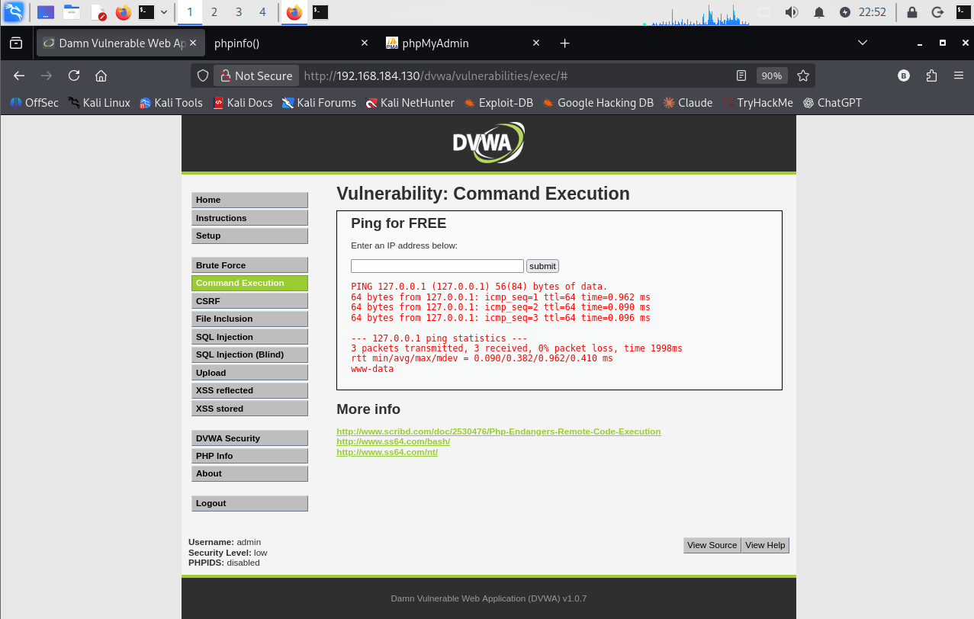
Figure 6: DVWA Command Execution — the injected command executes successfully; the output includes the service account www-data.

5.7 Weak / Default FTP Credentials — Dictionary Attack with Hydra (V-03)
Port 22 was re-confirmed open with a targeted scan (nmap -p 22 -sV 192.168.184.130), identifying OpenSSH 4.7p1 Debian 8ubuntu1. A small, purpose-built username list (user.txt) and password list (pass.txt) were then used with Hydra v9.7 against the FTP service: hydra -L user.txt -P pass.txt ftp://192.168.184.130.
Evidence: Hydra completed its single-task run in under a minute and reported one valid credential pair for FTP (port 21): login msfadmin, password [redacted — see note below]. The tool reported "1 of 1 target successfully completed, 1 valid password found."
Technical impact (confirmed): a valid, weak/default credential pair exists for an externally reachable FTP service.
Not verified: the credentials were not used to open an interactive FTP session, so post-authentication capability was not directly observed, though standard vsftpd behaviour would grant full account access.
Root cause: CWE-521 (Weak Password Requirements) and CWE-798 (Use of Hard-coded / Default Credentials).
Severity: Critical.
Note on methodology: the wordlists used were small and purpose-built for this exercise rather than an exhaustive, real-world password list; the result confirms a known default credential and should be read as a demonstration of default-credential risk, not as a measure of general password-cracking resistance (see Section 10).
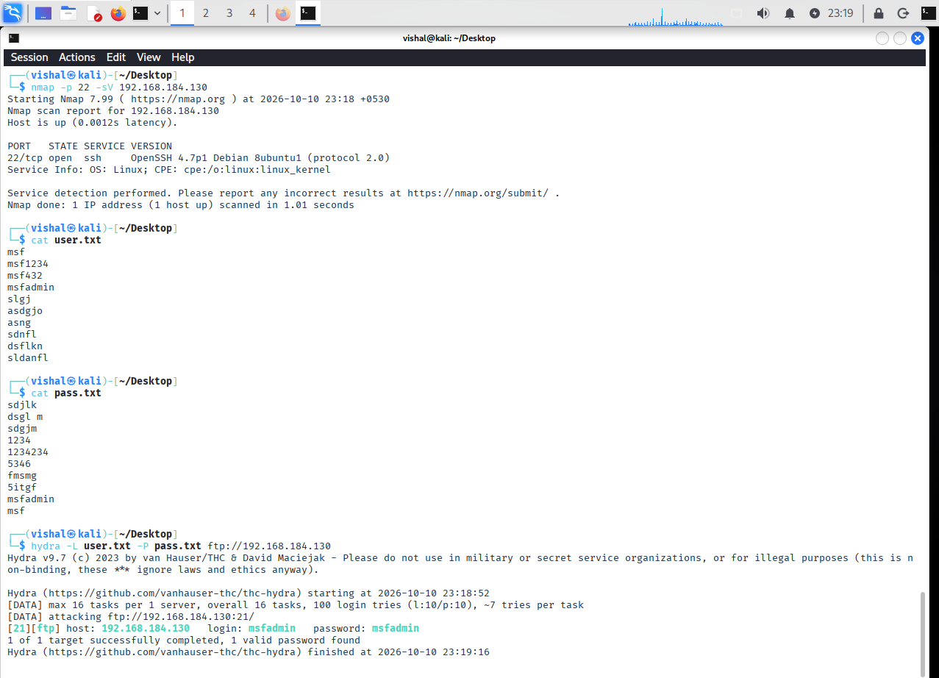
Figure 7: Hydra dictionary attack against FTP (port 21) recovers a valid default credential pair for the account msfadmin.
Responsible handling of credentials: the recovered password is masked as ms•••••n in the running text and tables of this report as standard professional practice for any version shared more widely; it remains visible only within the original command-output evidence in Figure 7 above, which cannot be redacted without altering the raw evidence.

6. Evidence and Screenshots Register

Every screenshot referenced in this report is embedded exactly once, at its point of discussion in Section 5. The register below is provided purely for traceability and audit purposes and does not repeat the images themselves.
Fig. | Source File | Description | Related Finding
1 | 1_Q20_nmap.png | Full Nmap service/version scan (-sV -sC) of 192.168.184.130 | V-06, V-07 (§5.1)
2 | 2_Q20_cmd.png | Nmap HTTP enumeration + curl verification of phpinfo.php and phpMyAdmin | V-04, V-05 (§5.2)
3 | 3_Q20_php.png | phpinfo() output showing PHP 5.2.4 configuration disclosure | V-04 (§5.3)
4 | 4_Q20_phpmyadmin.png | phpMyAdmin login page confirming unauthenticated reachability | V-05 (§5.4)
5 | 5_Q20_sql_injection.png | DVWA SQL Injection — five user records returned via 1' OR '1'='1' # | V-02 (§5.5)
6 | 6_Q20_command_execution.png | DVWA Command Execution — ping output showing www-data execution | V-01 (§5.6)
7 | 7_Q20_brut_fource_.png | Hydra dictionary attack against FTP recovering the msfadmin credential pair | V-03 (§5.7)

7. CVSS Scoring

CVSS v3.1 Base Scores below were calculated by the assessor from directly observed evidence only, using the standard CVSS v3.1 base-metric formula. Where post-exploitation impact (for example, write access or further lateral movement) was not independently tested, the Confidentiality / Integrity / Availability metrics are conservatively estimated from the nature of the flaw rather than from a separately confirmed action, and are flagged in the notes column. Findings with insufficient evidence to defend a specific numeric score are marked "Not scored" and rated qualitatively instead, per the assignment's instruction to treat CVSS as provisional.
ID | Vulnerability | CVSS v3.1 Vector | Score | Severity
V-01 | OS Command Injection | AV:N/AC:L/PR:L/UI:N/S:U/C:H/I:H/A:H | 8.8 | High
V-02 | SQL Injection | AV:N/AC:L/PR:L/UI:N/S:U/C:H/I:H/A:N | 8.1 | High
V-03 | Weak / Default FTP Credentials | AV:N/AC:L/PR:N/UI:N/S:U/C:H/I:H/A:N | 9.1 | Critical
V-04 | PHP Information Disclosure | AV:N/AC:L/PR:N/UI:N/S:U/C:L/I:N/A:N | 5.3 | Medium
V-05 | phpMyAdmin Exposure | Not scored — reachability only | — | Low (qual.)
V-06 | Backdoor Service (port 1524) | Not scored — identified via banner only | — | Critical (potential)
V-07 | Outdated / Legacy Services (aggregate) | Not scored — multiple components, no CVE mapping performed | — | Medium (qual.)

Notes on Provisional Scoring
- V-01, V-02: PR:L reflects that both DVWA modules require an authenticated application session at the Low security level used.
- V-02: impact beyond confirmed data disclosure (C:H) was not independently tested; I:H is estimated and should be re-validated.
- V-03: C:H / I:H reflect the expected access level for a standard vsftpd account, not an independently confirmed session; treat as provisional.
- V-05, V-06, V-07: not scored, as exploitation was not attempted and a defensible score cannot be built from reachability or banner data alone; qualitative severity is given instead (see Section 10).

8. Business Impact
Although carried out against a training system, these findings map directly onto risks a real organisation would face with the same weaknesses on a production host. The OS Command Injection and SQL Injection flaws (V-01, V-02) would let a remote attacker read and potentially modify application or customer data and pivot toward the underlying host — resulting in data breach, loss of data integrity, regulatory exposure, and reputational damage.
The recovered weak FTP credential (V-03) illustrates one of the most common real-world initial-access vectors: default or dictionary-guessable passwords on network-facing services. Combined with the pre-installed backdoor service on port 1524 (V-06), this shows how a single unpatched host can offer several independent paths to compromise, any one of which an attacker could use alone.
The information-disclosure findings (V-04, V-05) are lower severity individually, but they shorten an attacker's reconnaissance time and raise the odds that the higher-severity flaws above are found quickly. Together, the seven findings represent the layered, mutually reinforcing weaknesses that patch management, secure coding practice, credential hygiene, and network segmentation are specifically designed to prevent.

9. Remediation Recommendations

Recommendations below are grouped by priority, derived from the severity ratings in Section 7, and reference the finding IDs from Section 4.

Critical Priority
- Rotate or eliminate the default msfadmin credential; enforce a strong password policy and account lockout on FTP and every other remote-access service. (V-03)
- Investigate and remove any unauthorized listening service such as the one observed on port 1524; if a backdoor is confirmed, rebuild the host from a trusted, verified image rather than attempting in-place removal. (V-06)

High Priority
- Rewrite all SQL queries to use parameterized statements or prepared statements (or an ORM with equivalent protection); apply strict server-side input validation and run the application's database account under the principle of least privilege. (V-02)
- Eliminate direct operating-system command execution built from user input; where shelling out cannot be avoided, use safe language APIs, strict input allow-lists, and run the web server process with minimal OS privileges. (V-01)

Medium Priority
- Remove phpinfo.php and any other diagnostic or debug scripts from all publicly reachable paths before deployment; where such tooling is genuinely needed, restrict it by IP address / VPN and require authentication. (V-04)
- Upgrade PHP, Apache, and every other outdated service version identified during enumeration to current, vendor-supported releases, and formally retire end-of-life software. (V-04, V-07)

Low Priority / Defense-in-Depth
- Place phpMyAdmin and any similar administrative tooling behind IP allow-listing, VPN access, and multi-factor authentication, rather than exposing it directly on the application network. (V-05)
- Disable or tightly restrict legacy, cleartext protocols (Telnet, rsh/rexec, unauthenticated VNC, unauthenticated X11) in favour of modern, encrypted equivalents such as SSH and TLS-based remote access, and segment the network so database, management, and application tiers are not mutually reachable by default. (V-07)
- Implement centralized logging and alerting — for example on repeated failed logins or unusual outbound connections — to reduce the time needed to detect the attack patterns demonstrated in this report.

10. Assessment Limitations

This report should be read alongside the following boundaries, which define what was — and was not — tested:
- This was a time-boxed academic lab exercise, not an exhaustive security audit; an absence of findings does not imply an absence of vulnerabilities.
- Only the tools in Section 3 were used — no automated scanner, web proxy (e.g., Burp Suite), or exploitation framework (e.g., Metasploit) — so further weaknesses likely remain unexplored.
- Credential testing used a small, purpose-built wordlist, not an exhaustive real-world list; the result confirms a known default credential, not general password-cracking resistance.
- The phpMyAdmin exposure, the port 1524 backdoor, and the legacy-protocol observations were deliberately not exploited further, per this exercise's scope; real-world severity could differ under further testing.
- No denial-of-service, social-engineering, or physical-security testing was performed.
- This document is an academic coursework deliverable, not a certified, legally binding, or forensic security-audit report.

11. Conclusion

This VAPT exercise met its learning objective of simulating a structured, evidence-based security assessment against an authorized vulnerable lab target. Hands-on testing confirmed seven distinct findings ranging from Medium to Critical severity, most notably an OS Command Injection flaw, an SQL Injection flaw, and a weak/default FTP credential pair — each reproduced and documented first-hand rather than assumed.
Beyond the specific findings, the exercise provided practical, applied experience across the core phases of a real VAPT engagement: reconnaissance and service enumeration with Nmap, web-surface mapping with NSE scripts and curl, manual web-application exploitation within DVWA, dictionary-based credential testing with Hydra, and — not least — translating raw technical evidence into a structured report with severity ratings, business context, and prioritized remediation guidance suitable for a non-technical stakeholder audience.
The prioritized recommendations in Section 9, if applied in order, would materially reduce the risk represented by every finding in this report and reflect standard, widely accepted secure-development and secure-configuration practice.

